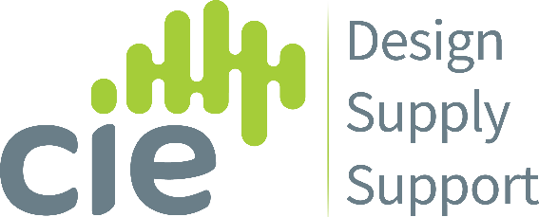

PRESS RELEASE
PR Contact: Chris Edwards
07918 054306
chris.edwards@cie-group.com
Date of Release: 10/03/2022 - FOR IMMEDIATE RELEASE
CIE announce a new UK distribution partnership with Carson Living
- Door intercom and access control to provide remote concierge service as Carson Living resident app comes to UK market
- Official UK launch at The Security Event, NEC Birmingham, 06 April
- Fully integrates with 2N and other leading third-party devices

CIE are proud to introduce Carson, the one-app resident experience and 24/7 remote concierge service, as it enters the UK & European market for the first time.
Seeing its official launch at The Security Event 2022 at the NEC Birmingham in April, Carson Living will be available in the UK through specialist IP Access Control distributors CIE-Group, adding to their growing portfolio of leading security brands including 2N, Axis, Akuvox and Quanika.
Carson fully integrates with 2N's leading IP access control & door intercom range as well as other third-party access devices, video monitoring and online payment brands - and has already taken the US MDU and multi-family building sector by storm.
Carson enables instant and streamlined property management in unmanned buildings and communication between residents, staff & management, as well as providing a 24/7 remote concierge support centre.
Commenting on CIE's latest addition to their growing range of IP solutions, CIE sales director Steve Collin commented: "Having provided innovative technology to the residential sector through 2N door entry solutions for many years, it's a natural fit for us to represent Carson in the 'high growth' build-to-rent market that provides developers and building owners the opportunity to improve on and provide services their tenants want and need together with reducing substantial costs with a clear return on investment. We can see this product being adopted as the go-to solution in the remote concierge market."
Founded in 2017 by successful property management software veterans, Carsons' new technology and remote concierge service brings the experience of living within large, staffed residential properties to smaller, unstaffed buildings, multi-dwelling & community properties at an affordable price.
Through the use of an intuitive mobile application and web-based user interface that integrates with best-in-class access control, electronic locks, cameras, intercoms, payment and back-end accounting systems, Carson enables property management staff and residents to communicate efficiently, make payments, submit and respond to service requests, open all integrated doors, manage guests and visitors' access, and to receive 24/7 deliveries at the buildings.
Changes of tenancy per apartment will update instantly on Carson when they are entered into the property manager's accounting system or web app, thereby seamlessly revoking or granting physical access to the properties.
The 2N range of IP intercoms - also available in the UK through CIE - are now fully integrated with Carson - streaming the video camera feed into the Carson app for residents and property staff, and connecting intercom calls to the Carson 24/7 call centre. With this integration, residents can enjoy all Carson functionality as well as 2N intercom features within the Carson app for Apple and Android smartphones. The 2N intercom directory names are continuously updated through Carson, based on residents’ move-ins and move-outs being updated on the property manager’s core accounting system. Also, residents can set specific hours for the Carson call centre to respond to 2N intercom calls on their behalf, a feature not available anywhere else in the market.
“Integrating with 2N’s intercoms is an important step in Carson’s mission to integrate best-in-class multifamily access, camera and intercom hardware, and enable residents to have all of their daily service needs in one app,” said Guy Blachman, Carson Founder and CEO. “2N provides a well-priced, reliable intercom with cutting-edge cloud technology, which integrated with Carson is a wonderful example of our One-App Resident Experience.”
For more information go to: https://cie-group.com/news/carson-remote-concierge
End

Notes to Editors:
What is a one-app resident experience?
Within the burgeoning MDU sector (‘multi-dwelling units’ – aka. ‘apartments’) there is a fast-growing demand for smart building, home automation and integrated systems throughout the building and within each individual residence. In addition, resident expectations to control their home technology and book services from their smartphone has become a key factor in high-end building specifications.
Smart home and smart building technologies will inevitably offer their own proprietary app – but with more and more smart-controlled devices, our phones are becoming swamped with individual control apps and interfaces.
A ‘one-app resident experience’, therefore, addresses the increasing demand for ‘everything in one place’ services control, appointment/room booking and payment systems all within a single smartphone application.
What is Remote Concierge?
The apartment building concierge is no longer limited to the expectations of the luxury sector, with more and more MDUs (multi-dwelling units – or ‘apartments blocks’ to you and I!) employing a concierge in the building lobby to provide visitor, delivery and resident services.
Building concierge services are increasingly seen as a differentiator for potential residents – and often now a ‘necessity’ to respond to the burgeoning trend for food & parcel home deliveries.
However, with personnel costs to support on-site concierge often exceeding £150,000~£200,000 per annum, the remote concierge service (sometimes also referred to as ‘virtual concierge’ or ‘remote doorman’) is now offering a genuine alternative to reduce costs, whilst providing a combination of ‘in-app’ and remote team services accessed via resident smartphones and building door intercom & access control devices.

Press contacts:
Chris Edwards, Marketing Director, CIE-Group Tel: +44 (0)115 9770075 Email: chris.edwards@cie-group.com
Katie Cooke, Digital Marketing & Events Co-ordinator, CIE-Group Tel: +44 (0)115 9770075 Email: katie.cooke@cie-group.com
About Carson
Carson is the new technology standard for managing multiple unstaffed or multi-dwelling / community residential properties. The company was founded by seasoned and successful property management software entrepreneurs, residential property owners and hardware integrators. Headquartered in New York City, Carson is at the forefront of enhancing residents' living experience in unstaffed properties.
About CIE-Group
Established back in 1964 as a specialist audio and electronics distributor, CIE has become one of the most vibrant and innovative professional Audio Visual & Security distributors in the UK.
As a true 'value-added' distributor, providing our customers with exemplary products and service is the key to our success with a team of true experts in product, specification, design and integration.
CIE has been instrumental in the migration of commercial audio and public address from analogue to I.P. technology, working with leading audio-over-IP innovators such as 2N, Akuvox, CYP, Inter-M and Axis Communications. For more information about CIE, visit us online at www.cie-group.com

View the Carson Living introduction video
Supporting Images:
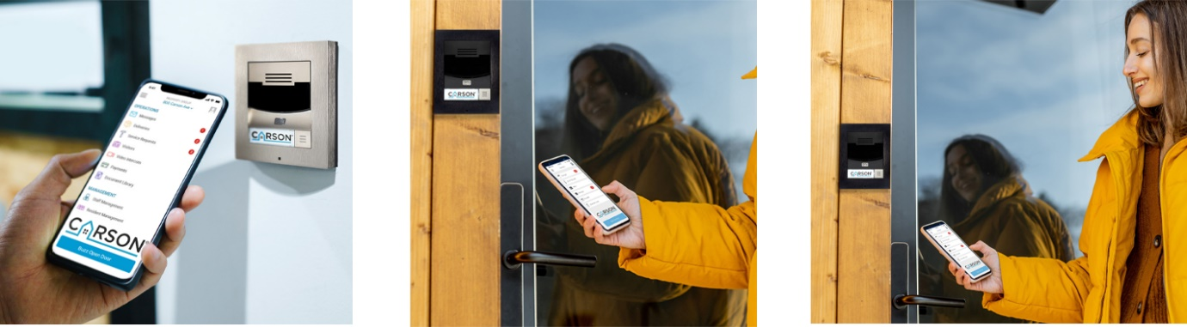
Click here to download high resolution supporting images.

